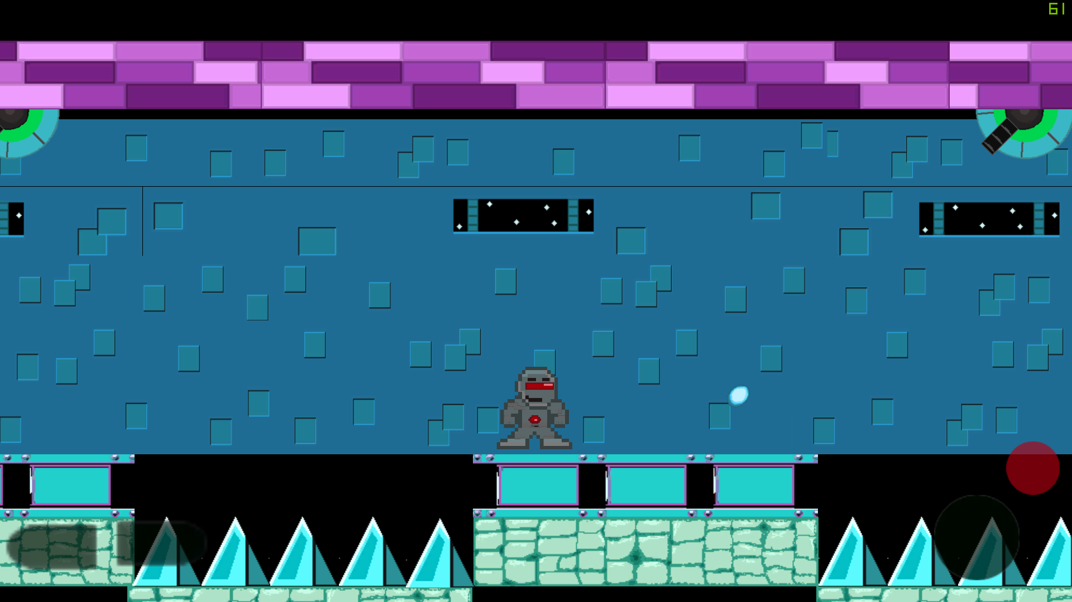

This game was made for the Android Platform with Unity 2D engine. The game is a platformer with the goal to get through the level without being hit. I developed this game for my Embedded game design course where the focus was all on embedded game from consoles to mobile. First project created in Unity.